Surprise Interjections

🔹 What Are Surprise Interjections?
# Source: AI Source: Provided by: [Data Path: Persons Table -> ID Column: 1, Name_En Column: Motasem Essam] -> From: [Chatgpt (GPT-4-turbo)] on [7/28/2025]
Surprise interjections are short expressions used to show a sudden feeling of shock, amazement, excitement, or unexpectedness.
They reflect an immediate emotional reaction to something surprising — whether good or bad.

✅ Key Features
# Source: AI Source: Provided by: [Data Path: Persons Table -> ID Column: 1, Name_En Column: Motasem Essam] -> From: [Chatgpt (GPT-4-turbo)] on [7/28/2025]
- Express sudden emotion: amazement, shock, wonder, disbelief
- Common in conversations, stories, and drama
- Usually followed by an exclamation mark (!) or a pause

🧩 Common Surprise Interjections
# Source: AI Source: Provided by: [Data Path: Persons Table -> ID Column: 1, Name_En Column: Motasem Essam] -> From: [Chatgpt (GPT-4-turbo)] on [7/28/2025]
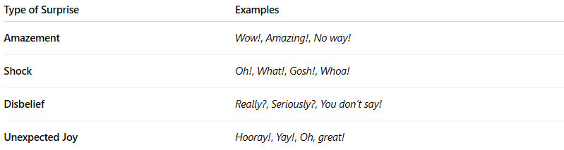
Type of Surprise | Examples
Amazement | Wow!, Amazing!, No way!
Shock | Oh!, What!, Gosh!, Whoa!
Disbelief | Really?, Seriously?, You don’t say!
Unexpected Joy | Hooray!, Yay!, Oh, great!

📚 Example Sentences
# Source: AI Source: Provided by: [Data Path: Persons Table -> ID Column: 1, Name_En Column: Motasem Essam] -> From: [Chatgpt (GPT-4-turbo)] on [7/28/2025]
- Wow! That was incredible! (positive amazement)
- Oh! I didn’t expect to see you here. (neutral surprise)
- What! He quit his job? (shock/disbelief)
- Gosh! That was close! (mild shock)
- No way! Are you serious? (strong disbelief)

